November  2023 | 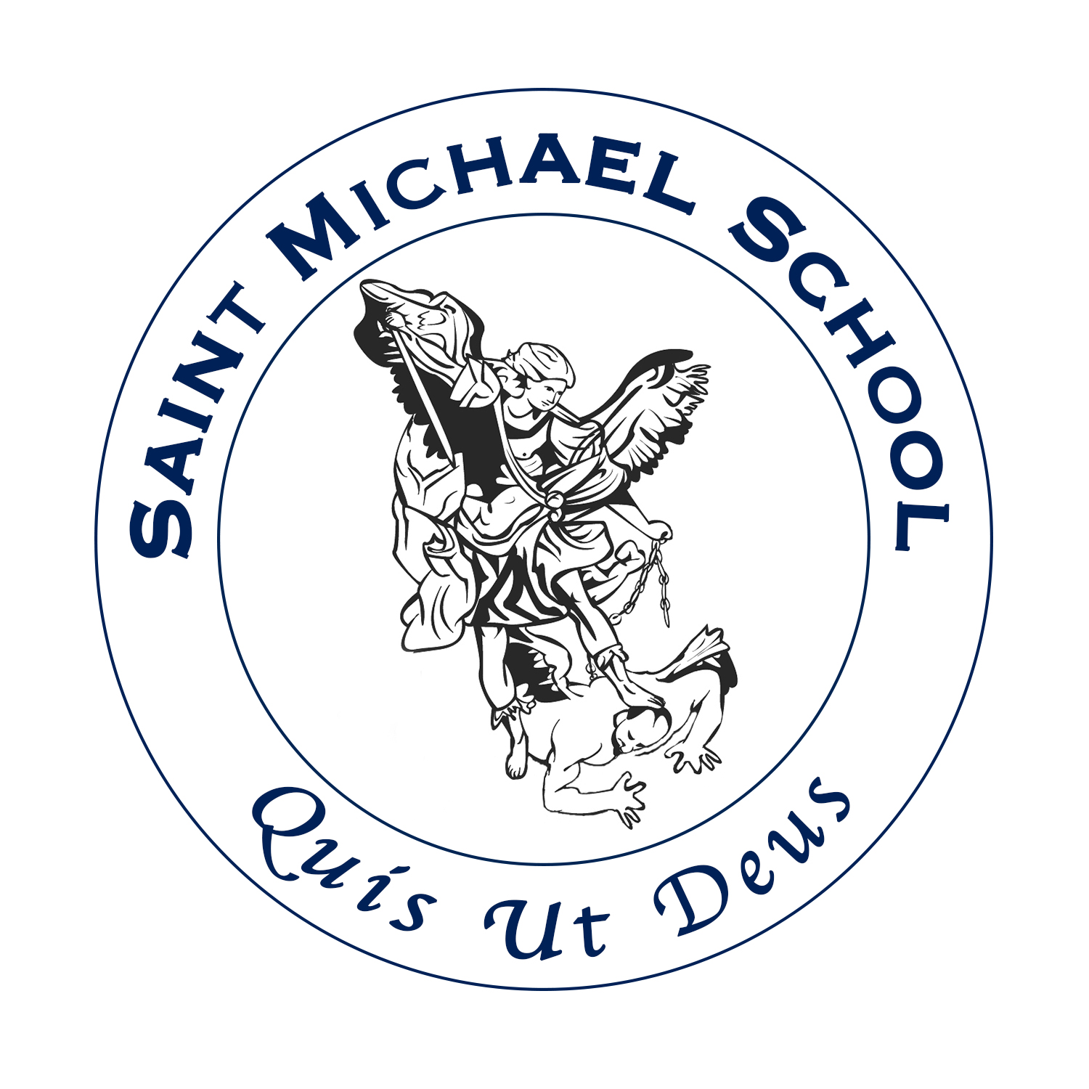
Sunday | Monday | Tuesday | Wednesday | Thursday | Friday | Saturday
 |  |  | 1 | 2 | 3 | 4
 |  |  | All Saints Day  All Souls Day Mass & Candlelight Procession 6:30PM | All Souls Day | Picture Retake Day  Casino Bus Trip | St. Joseph’s Parish Spaghetti & Meatball Dinner
5 | 6 | 7 | 8 | 9 | 10 | 11
Daylight Savings Begins | PTO Meeting 6:30PM | Parent/Teacher Conference  Early Dismissal 11:30AM |  | Diocesan Professional Development  -No School | Veterans’ Day  -No School | Holy Ghost Dinner
12 | 13 | 14 | 15 | 16 | 17 | 18
Second Sunday Social at St. Joseph Parish | 8th Grade Confirmation Class 7PM - 9PM | Faculty/Staff Mtg  -no extra help | Share Our Faith 6:30PM at St. Joseph Parish Hall |  | Pies & Cookies Pick Up  2PM – 5PM  Jr. & Sr.Youth Group 6PM – 8PM
19 | 20 | 21 | 22 | 23 | 24 | 25
 |  | Thanksgiving Mass 6:30PM at St. Michael Church | Professional Development Early Dismissal 11:30AM  Thanksgiving Mass 6:30PM at St. Joseph Church | Thanksgiving Day  -No School | Thanksgiving Break  -No School
26 | 27 | 28 | 29 | 30
Faculty/Staff Mtg
-no extra help
Virtue of the Month: Gratitude
Prayer: Prayers for the dead, “Eternal rest grant unto them, O Lord, And may perpetual light shine upon them. May the souls of all the faithful departed, through the mercy of God, rest in peace. Amen!”
Song: Now Thank we all our God, Jesus Remember me, Lord of all Hopefulness

